Effective Date:  19-July-2011 | No. of Revisions:  2 |  | 
Document Catalog No:
SMU/IITS/LMS/Technical Guide/2011/007
Author: Steve Siu
Last Date of Revision: 5 Aug 2011
Last Revision Done by: Steve Siu
SMU Single Sign On
Integration Guide

IITS Main Office  SINGAPORE MANAGEMENT UNIVERSITY  Administration Building, Level 11  81, Victoria Street  Singapore 188065  Phone: 65-6828 1930  Email: iits@smu.edu.sg |  | Please visit the Helpdesk website for more information:  http://www.smu.edu.sg/IITS/helpdesk_support/index.asp

Table of Contents
1. Introduction 3
2. Overview 3
3. Creating an SSO application entry 5
4. Using the SSO API 6
5. Generating the Signature 6
6. Validating the Timestamp 8
7. Sample Program 8
8. Other Resources 10
9. Feedback 10
- Introduction

This document provides detailed information on how to implement a Single Sign On (SSO) application via the SMU SSO API framework created by the Learning Systems and Technologies Team of IITS. The SMU SSO framework implements a simplified version of the OAuth 1.0 specification (http://oauth.net/) for allowing authentication of SMU users via an open and simple authorization API.

- Overview

A typical OAuth 1.0 Authentication is done in three steps:
- The Consumer obtains an unauthorized Request Token.
- The User authorizes the Request Token.
- The Consumer exchanges the Request Token for an Access Token.
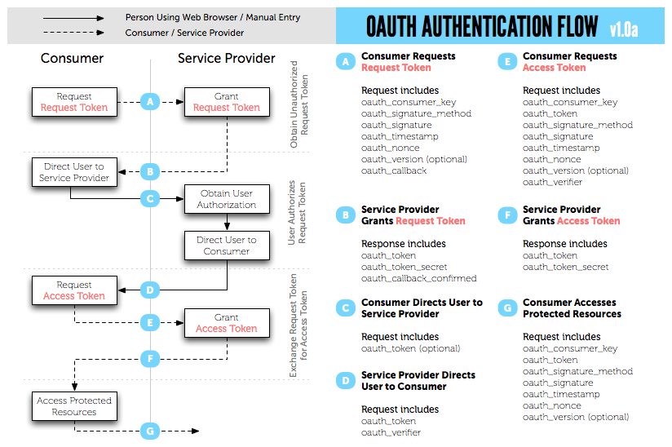

Each request in the OAuth authentication requires an exchange of request and access token between the consumer application and the server. This requires a lot of programming effort in developing the consumer and the server applications.
As the SMU SSO only involves one request (consumer to server) and one response after successful authorization (server to consumer), we do it without the token exchange in order to simplify the implementation.
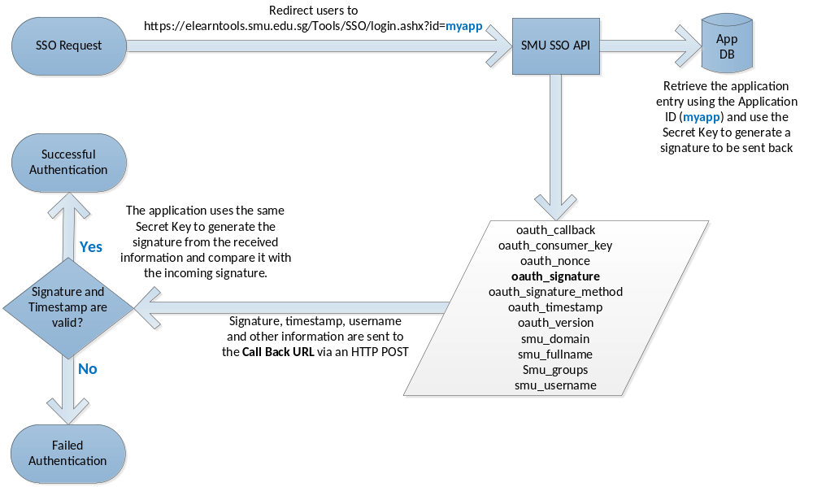

The simplified SSO authentication flow is illustrated in the above diagram. The steps are described below:
- The consumer application redirects the user to the following URL:
https://elearntools.smu.edu.sg/Tools/SSO/login.ashx?id=myapp
where myapp is the Application ID (or the oauth_consumer_key) that you can create using the SSO Tool.
- The server application (SMU SSO API) authenticates the user and sends the following information back to the Call Back URL upon successful authentication.

Parameter | Description
oauth_callback | This is the Call Back URL of the SSO application entry created using the SMU SSO Tool.
oauth_consumer_key | This is the Application ID of the SSO application entry created using the SMU SSO Tool.
oauth_nonce | A random number generated by the API
oauth_signature | A signature created according to the OAuth 1.0 specification for HMAC-SHA1.  The signature was encrypted by the SMU SSO API using the Secret Key of the SSO application entry created using the SMU SSO Tool.  The consumer application uses the same Secret Key to generate a signature and compares it with this.
oauth_signature_method | Must be “HMAC-SHA1”
oauth_timestamp | The timestamp when the authenticated was done.  It is the total number of seconds from 1 Jan 1970 GMT.
oauth_version | Must be “1.0”
smu_domain | SMU Domain (SMUSTU or SMUSTF)
smu_fullname | Full name of the user (e.g. FRANCIS LEE)
smu_groups | SMU activity directory groups (e.g. stu.sis.2011)
smu_username | SMU username (e.g. francislee.2010)

- The consumer application checks if the timestamp and the signature are valid according to the OAuth 1.0 specification for HMAC-SHA1 signing.
- Once the validation is done, the consumer application allows the user to login.
In this simplified implementation of the OAuth 1.0, we do not verify the request. We accept all the requests as long as the Application ID (the consumer key) exists. Using this Application ID, we can retrieve the Call Back URL and the Secret Key.

- Creating an SSO application entry

Before you can use the SMU SSO API, you will need to obtain the following application entry:

Field | Description
Application ID | This is a unique ID to identify your application (max. 20 chars)
Application Name | Name of your application.
Secret Key | This is a key to be used by the system to encrypt the information to be sent to the Call Back URL. Your application also uses this Secrete Key to validate the signature from the SSO API.
Call Back URL | The URL of your application that will process the data sent by the SSO API. You must include the “http” or “https”.

SMU staff will be able to create this application entry using the SMU SSO Tool at https://elearntools.smu.edu.sg/Tools/SMUSSO/. For details, please contact the LMS administrator at elearn@smu.edu.sg.

- Using the SSO API

To call the SSO API, you use the following URL:

https://elearntools.smu.edu.sg/Tools/SSO/login.ashx?id=appid

where appid is the Application ID mentioned in Section 3.

- Generating the Signature

The signature is used to verify if the incoming information is valid. The signature must be generated according to OAuth 1.0 specification for HMAC-SHA1 (http://oauth.net/core/1.0a/#anchor15).

The following paragraphs related to HMAC-SHA1 signature were extracted from the OAuth 1.0 Specification.

HMAC-SHA1
The HMAC-SHA1 signature method uses the HMAC-SHA1 signature algorithm as defined in [RFC2104] (Krawczyk, H., Bellare, M., and R. Canetti, “HMAC: Keyed-Hashing for Message Authentication,” .) where the Signature Base String is the text and the key is the concatenated values (each first encoded per Parameter Encoding (Parameter Encoding)) of the Consumer Secret and Token Secret, separated by an '&' character (ASCII code 38) even if empty.

Generating Signature
oauth_signature is set to the calculated digest octet string, first base64-encoded per [RFC2045] (Freed, N. and N. Borenstein, “Multipurpose Internet Mail Extensions (MIME) Part One: Format of Internet Message Bodies,” .) section 6.8, then URL-encoded per Parameter Encoding (Parameter Encoding).

Verifying Signature
The Service Provider verifies the request by generating a new request signature octet string, and comparing it to the signature provided by the Consumer, first URL-decoded per Parameter Encoding (Parameter Encoding), then base64-decoded per [RFC2045] (Freed, N. and N. Borenstein, “Multipurpose Internet Mail Extensions (MIME) Part One: Format of Internet Message Bodies,” .) section 6.8. The signature is generated using the request parameters as provided by the Consumer, and the Consumer Secret and Token Secret as stored by the Service Provider.
Summary of the Algorithm
In short, the system generates a base signature in the following format and then encodes it with the consumer secret using HMAC-SHA1 algorithm:

[http method]&[call back url]&[concatenated key-value pairs of all parameters]

The list of key-value pair parameters used to generate the base signature was given in the table in Section 2. Note that the parameters must be sorted in alphabetical order. According to the OAuth1.0 specification, the parameters must be URL encoded before applying URL encoding on the signature. Therefore, the URL encoding applies on the key-value pairs twice. The pseudo code below illustrates the algorithm:

[http method]&URL Encode([call back url])& URL Encode([URL Encode(key1=value1)
&URL Encode(key2=value2) &…&URL Encode(key[n]=value[n])])

Key | Value
oauth_callback | http://localhost:2395/SSOSample/Default.aspx
oauth_consumer_key | test
oauth_nonce | 8928377
oauth_signature | ycnJ1rMbRyQ9sq3bzNzGKCBuJgQ=
oauth_signature_method | HMAC-SHA1
oauth_timestamp | 1312363115
oauth_version | 1.0
smu_domain | SMUSTF
smu_fullname | Mr Steve Siu
smu_groups | itsprodusers,ADMIN_STAFF,ADM_ZONE,SMU_FACULTY_ADMIN,  ReportingGroup,stf.cit,stf.lst,EAVinstall,stf.contract,stf.oel,  stf,wlan_staff_admin,staff,VC_Staff_Student
smu_username | stevesiu

This is an example of the key-value pairs for the above parameters:

oauth_callback=http%3A%2F%2Flocalhost%3A2395%2FSSOSample%2FDefault.aspx&oauth_consumer_key=test&oauth_nonce=8928377&oauth_signature_method=HMAC-SHA1&oauth_timestamp=1312363115&oauth_version=1.0&smu_domain=SMUSTF&smu_fullname=Mr%20Steve%20Siu%20&smu_groups=itsprodusers%2CADMIN_STAFF%2CADM_ZONE%2CSMU_FACULTY_ADMIN%2CReportingGroup%2Cstf.cit%2Cstf.lst%2CEAVinstall%2Cstf.contract%2Cstf.oel%2Cstf%2Cwlan_staff_admin%2Cstaff%2CVC_Staff_Student&smu_username=stevesiu

Note that the oauth_callback parameter is URL encoded and the oauth_signature must not be included according to the specification.

The base signature is:

POST&http%3A%2F%2Flocalhost%3A2395%2FSSOSample%2FDefault.aspx&oauth_callback%3Dhttp%253A%252F%252Flocalhost%253A2395%252FSSOSample%252FDefault.aspx%26oauth_consumer_key%3Dtest%26oauth_nonce%3D8928377%26oauth_signature_method%3DHMAC-SHA1%26oauth_timestamp%3D1312363115%26oauth_version%3D1.0%26smu_domain%3DSMUSTF%26smu_fullname%3DMr%2520Steve%2520Siu%2520%26smu_groups%3Ditsprodusers%252CADMIN_STAFF%252CADM_ZONE%252CSMU_FACULTY_ADMIN%252CReportingGroup%252Cstf.cit%252Cstf.lst%252CEAVinstall%252Cstf.contract%252Cstf.oel%252Cstf%252Cwlan_staff_admin%252Cstaff%252CVC_Staff_Student%26smu_username%3Dstevesiu

The base signature is then encrypted using the Secret Key (e.g. password in this example) and a Token Secret separated by an & via the HMAC-SHA1 algorithm. The token secret is always empty in our case as we are not using token in any requests/responses. The pseudo code is as follow:

HMAC-SHA1([base signature], "[Secret Key]&[Token Secret]");

For our example, it’s
HMAC-SHA1([base signature], “password&”)
The encrypted value of the above base signature becomes:

ycnJ1rMbRyQ9sq3bzNzGKCBuJgQ=

- Validating the Timestamp

The timestamp is the number of seconds from 1 Jan 1970 GMT to the time when the authentication is done on the server. You will need to ensure the difference between your local timestamp and the incoming timestamp fall within an acceptable interval (e.g. 30 seconds). You may adjust the allowance interval according to the time difference between your server and the API server. In general, it is not recommended to set the interval more than 120 seconds (i.e. +/- 120 seconds)

You may implement a more secure policy to ensure that each timestamp can only be used once or twice for each user.

- Sample Program

A sample program was written for demonstrating the implementation of the above simplified OAuth1.0 SSO.

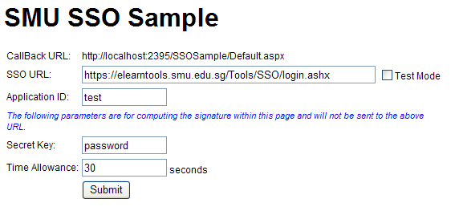

You can turn on the “test mode” by ticking the checkbox for viewing the incoming parameters without submitting them to the call back URL.

The incoming information from the SMU SSO API is listed below:

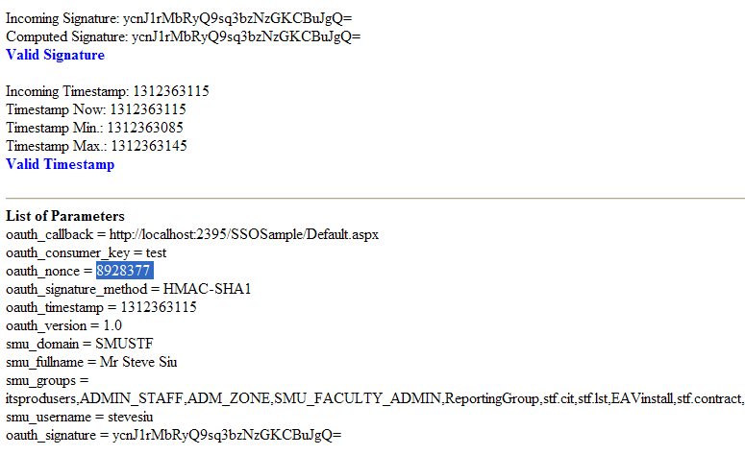

This sample program was written in ASP.NET 3.5 (C#). To run the program, open it in Microsoft Visual Studio.

Go to File > Open Web Site > Select the folder > Right click “Default.aspx” > Select “View in Browser”

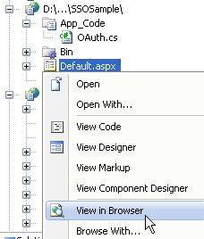
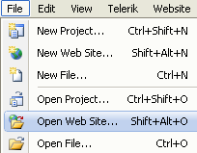

The OAuth.cs in the App_Code folder contains the source code for the implementation of the algorithm mentioned above.
The code was based on the basic C# class contributed by Eran Sandler’s at http://oauth.net/code/.
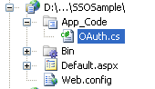

The latest sample program can be obtained from the LMS Administrator at elearn@smu.edu.sg.

- Other Resources

There are OAuth1.0 libraries written in different languages (Java, PHP, Perl, etc) contributed by different people. You can find them at the OAuth website at http://www.oauth.net/code/.

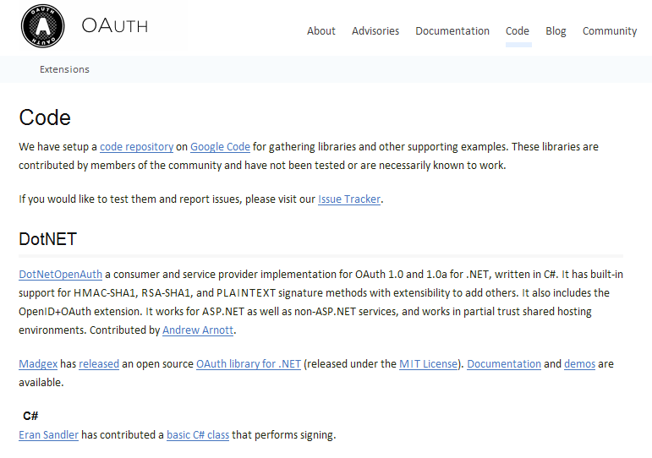

- Feedback

If you have any suggestions/feedback about this tool, please email us at: elearn@smu.edu.sg.

